

Please complete the information herein and email to: sales@cesco.co.za

Customer Information
End User:
 | Company Name | Contact Person | Position
Address:
 | Business Address | Department
 | City | Province | Postal Code
Direct Phone: |  | Email address:

Sales Person:

Rotating Equipment Information
This information is being requested to better select the Bearing Isolator. Please complete as accurately as possible:

Type of Equipment
☐ | Centrifugal Pump, Horizontal | ☐ | Centrifugal Pump, Vertical | ☐ | Gearbox, Horizontal
☐ | Gearbox, Vertical | ☐ | Other*
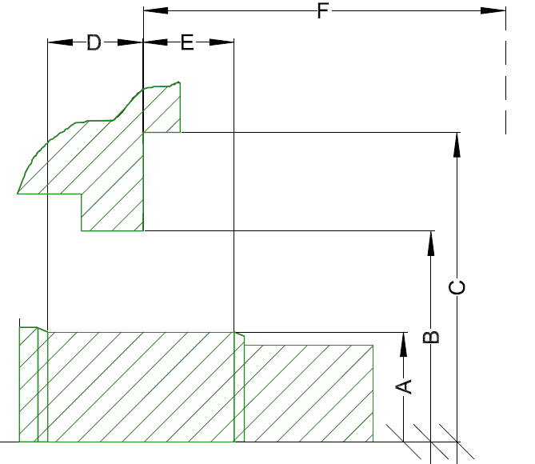
* Please specify:

Dimensional Information in millimeters:
A-shaft diameter:
B-Housing inside diameter:
C-Distance to diametrical obstruction:
D-Maximum depth to fit:
E-Distance to shaft step:
F- closest obstruction from housing:

Type of Equipment:

Manufacturer:

Type of equipment:

Size or Model:

Type of Industry:

Shaft speed:

Maximum axial movement:

Maximum radial movement:

Additional Information:
- What is currently installed:
- If successful, how many additional units will be required:
- Anything else to add?

Compiled by:
Date: Click or tap to enter a date.

